

Gateway determination report – PP-2024-969

Additional Permitted Use for centre-based childcare facility at Lot 150 DP750182, 21 Noble Street, Eugowra

June 24

Published by NSW Department of Planning, Housing and Infrastructure

[dpie.nsw.gov.au](http://www.dpie.nsw.gov.au/)

Title: Gateway determination report – PP-2024-969

Subtitle: Additional Permitted Use for centre-based childcare facility at Lot 150 DP750182, 21 Noble Street, Eugowra

© State of New South Wales through Department of Planning, Housing and Infrastructure 2024. You may copy, distribute, display, download and otherwise freely deal with this publication for any purpose, provided that you attribute the Department of Planning, Housing and Infrastructure as the owner. However, you must obtain permission if you wish to charge others for access to the publication (other than at cost); include the publication in advertising or a product for sale; modify the publication; or republish the publication on a website. You may freely link to the publication on a departmental website.

Disclaimer: The information contained in this publication is based on knowledge and understanding at the time of writing (April 24) and may not be accurate, current or complete. The State of New South Wales (including the NSW Department of Planning, Housing and Infrastructure), the author and the publisher take no responsibility, and will accept no liability, for the accuracy, currency, reliability or correctness of any information included in the document (including material provided by third parties). Readers should make their own inquiries and rely on their own advice when making decisions related to material contained in this publication.

Acknowledgment of Country

The Department of Planning, Housing and Infrastructure acknowledges the Traditional Owners and Custodians of the land on which we live and work and pays respect to Elders past, present and future.

Contents

1 Planning proposal 2

1.1 Overview 2

1.2 Objectives of planning proposal 2

1.3 Explanation of provisions 2

1.4 Site description and surrounding area 3

1.5 Mapping 4

1.6 Background 5

2 Need for the planning proposal 5

3 Strategic assessment 6

3.1 Regional Plan 6

3.2 Local 6

3.3 Section 9.1 Ministerial Directions 7

3.4 State environmental planning policies (SEPPs) 8

4 Site-specific assessment 9

4.1 Environmental 9

4.2 Social and economic 10

4.3 Infrastructure 10

5 Consultation 11

5.1 Community 11

5.2 Agencies 11

6 Timeframe 11

7 Local plan-making authority 11

8 Assessment summary 12

9 Recommendation 12

Table 1 Reports and plans supporting the proposal

|  |
| --- |
| Relevant reports and plans |
| Planning Proposal Eugowra Final Version |
| Council report to support Gateway |
| Council resolution to support Gateway |
| Preliminary Contamination Investigation |
| Final Strategic Bush Fire Study |

# Planning proposal

## Overview

Table 2 Planning proposal details

|  |  |
| --- | --- |
| LGA | Cabonne |
| **PPA** | Cabonne Shire Council |
| **NAME** | Eugowra Preschool APU (0 homes, 0 jobs) |
| **NUMBER** | PP_2024_969 |
| **LEP TO BE AMENDED** | Cabonne LEP 2012 |
| **ADDRESS** | 21 Noble Street, Eugowra. |
| **DESCRIPTION** | Lot 150 DP 750182 |
| **RECEIVED** | 8/05/2024 |
| **FILE NO.** | IRF24/675 |
| **POLITICAL DONATIONS** | There are no donations or gifts to disclose and a political donation disclosure is not required |
| **LOBBYIST CODE OF CONDUCT** | There have been no meetings or communications with registered lobbyists with respect to this proposal |

## Objectives of planning proposal

The planning proposal contains objectives and intended outcomes that adequately explain the intent of the proposal.

The objective of the planning proposal is to permit development for the purpose of a centre-based childcare facility on the subject land, being Lot 150 DP750182, 21 Noble Street, Eugowra, (being part of Crown land under the trustee of Cabonne Council as public recreation for the Eugowra Showground). This will be achieved through an additional permitted use clause under Schedule 1 (Additional permitted use) of the Cabonne Local Environmental Plan 2012 (Cabonne LEP 2012).

The objectives of this planning proposal are clear and adequate.

## Explanation of provisions

The planning proposal seeks to amend the Cabonne LEP 2012 to insert an additional permitted use (centre- based child care facility) under schedule 1 of the LEP for the subject site. There are no changes proposed to any other part of the LEP. The site will remain zone RE2 Private Recreation. There is no minimum lot size applicable to the land.

The planning proposal contains an explanation of provisions that adequately explains how the objectives of the proposal will be achieved.

## Site description and surrounding area

The subject site forms part of the Eugowra Showground, which is a Crown Reserve owned by the State of NSW for the purpose of public recreation and managed by Cabonne Council for the benefit of the community for the purposes of the Crown Land Management Act 2016. The showground land contains two allotments being Lot 150 DP 750182 which is the land subject to this planning proposal and is vacant land located on the corner of Noble Street and Nanima Road, and the main showground land being Lot 71 DP 750182. Combined the area of the public recreation reserve is 40 ha, while Lot 150 has an area of 3.2ha.

A draft Plan of Management prepared in June 2023 applies to the Eugowra Showground (Reserve D590015) and identifies both allotments of the showground land as categorised as Showground and General Community Use. The land is classified as community land under the Local Government Act 1993 and s3.22(1) of the Crown Land Management Act 2016.

The draft Plan of Management for the Eugowra Showground includes both the temporary location of demountable buildings to house a temporary childcare centre (contained within Lot 71), while also recognizing the Eugowra community’s need for a permanent childcare facility and identifies a long-term site within Lot 150 DP 750182.

The site is located on the eastern edge of the village of Eugowra. Lot 51 is vacant land and is used intermittently for agriculture purposes. In the aftermath of the 2022 natural disaster that impacted Cabonne and in particular Eugowra, a portion of the Showground site was used for disaster recovery temporary offices and equipment storage.

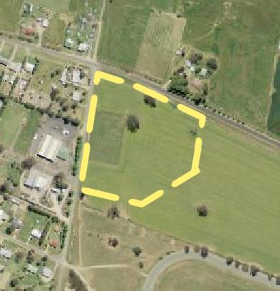

Figure 1 Subject site (source: NSW Planning Portal Spatial Viewer)

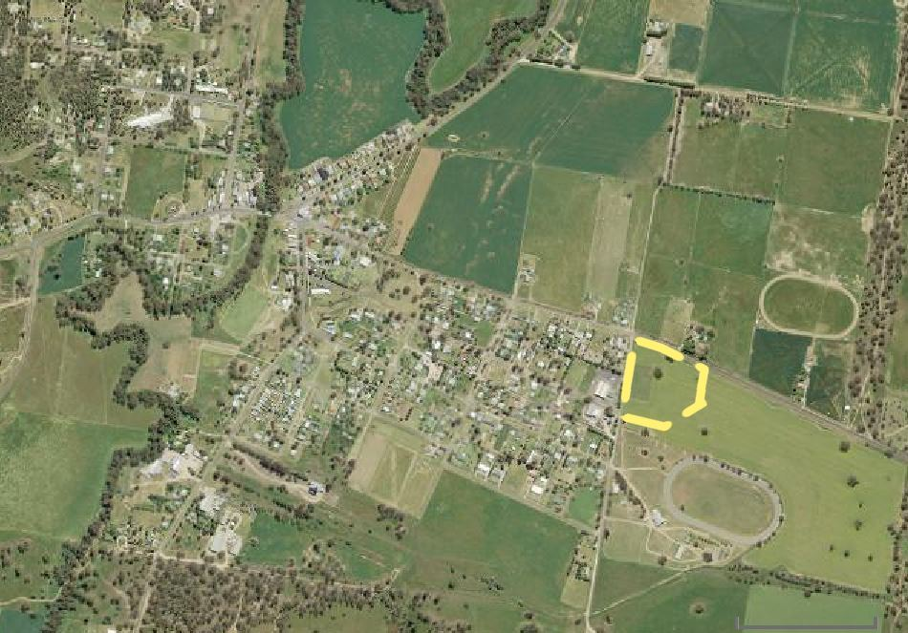

Figure 2 Site context (source: NSW Planning Portal Spatial Viewer)

## Mapping

No mapping changes are proposed as part of the planning proposal.

Current mapping within the Cabonne LEP, showing land zoning (zone RE2 Private recreation) will continue to apply to the site. No minimum lot size applies to the subject land.

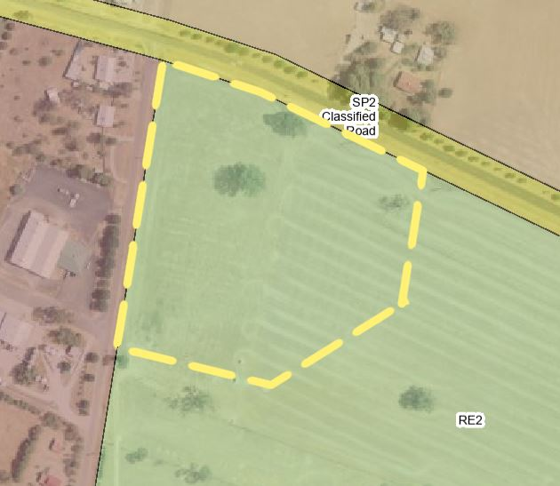

Figure 3 Current zoning map

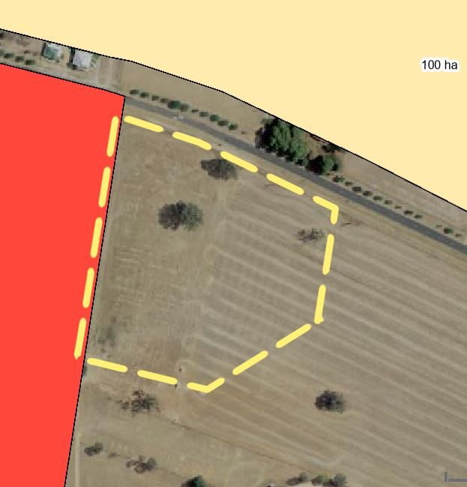

Figure 4 Current minimum lot size map

## Background

In 2022, the Eugowra flood event forced the relocation of the preschool to be relocated temporarily to the Eugowra Showground. A temporary approval was in place for a period of 3 years for the preschool, while a permanent site was found.

Following investigations, it was identified that the showground was the most appropriate place for the preschool to permanently operate, and this planning proposal seeks to modify the Cabonne LEP 2012 to formalise the permanent arrangement.

Details are provided within the planning proposal and Council Report documents forming this application.

# Need for the planning proposal

The planning proposal is not the result of a local strategic study or report. The need for the facility is an outcome of the Cabonne Flood Recovery Plan, and a key issue for the Eugowra community as part of its flood recovery measures.

The subject land is currently zoned RE2 Private Recreation and is situated on the eastern edge of the village of Eugowra. The site and the adjacent Crown land allotment is the location of the Eugowra Showground and trotting track.

The objective of enabling the relocation of the community-based Eugowra pre-school to the site can only be achieved by an amendment to the Cabonne LEP 2012 via a planning proposal.

Council’s report details that the existing temporary facility was provided development consent on a temporary basis as a community facility (pre-school) that this definition does not provide flexibility in its management/operation, and as such is a restrictive definition suitable for a short term only until the land use definition of a centre based childcare facility can be permitted on the site via a planning proposal. Council’s preference is therefore for an amendment to Schedule 1 Additional Permitted Uses, which can only be achieved via an amendment to the Cabonne LEP 2012 via a planning proposal.

# Strategic assessment

## Regional Plan

The planning proposal has addressed the superseded Central West and Orana 2036 Regional Plan and the current Central West and Orana Regional Plan 2041.

The LEP Guidelines require a planning proposal to demonstrate how the proposed amended LEP will give effect to the strategic planning framework to ensure that the proposal has strategic merit.

The following table provides an assessment of the planning proposal against relevant aspects of the Central West and Orana Regional Plan 2041. The proposal is considered to be consistent with the current regional plan.

Table 3 Regional Plan assessment

|  |  |
| --- | --- |
| Regional Plan Objectives | Justification |
| Objective 7 - Plan for resilient places and communities | The planning proposal is consistent with this objective as it proposes to locate the childcare facility in an area which is more resistant to flooding and was unaffected during the 2022 flood. |
| Objective 19 - Protect agricultural production values and promote agricultural innovation, sustainability and value-add opportunities | The planning proposal is consistent with this objective as the proposed childcare facility is to be located on land zoned for recreation and avoids land zoned for agricultural proposes. |

## Local

The proposal states that it is consistent with the following local plans and endorsed strategies. It is also consistent with the strategic direction and objectives, as stated in the table below:

Table 4 Local strategic planning assessment

|  |  |
| --- | --- |
| Local Strategies | Justification |
| Cabonne Local Strategic Planning Statement (LSPS) | The planning proposal is considered to be consistent with the following Planning Priorities detailed in the Cabonne LSPS:   * 1. Support the diversification in agriculture and protect agricultural land from urban encroachment. * 6. Ensure that infrastructure and facilities cater for the changing needs of our community. * 7. Protect and enhance our landscape, biodiversity and waterways. * 8. Manage natural hazards to mitigate their impacts on our communities.   The planning proposal is considered to be generally consistent with the Cabonne LSPS as the planning proposal:   * Is located on land which has previously been cleared and not zoned for agricultural use, * will provide for an increasing need for child care positions, and * is located in an area which is resilient to flooding. |
| Cabonne Settlement Strategy 2021 - 2041 | The Cabonne Settlement Strategy aims to guide council and Government on future commercial and residential growth over the next 20 years. The Strategy identifies the showground land as suitable for use for community purposes. The planning proposal is therefore considered generally consistent with this strategy. |
| Cabonne Community Strategic Plan 2022 - 2032 | The Cabonne Community Strategic Plan aims to identify the community's main priorities and aspirations for the future, and to plan strategies for achieving those goals.  Strategic Direction 3 contains goals and objectives encouraging a connected, healthy and well supported community for people of all ages. The proposal is consistent with this strategic direction as it will provide opportunity for families and young children to engage in a connected manner.  Specifically, Strategic Direction 3.5 states: *Cabonne's children have access to childcare and children's services that meet the needs of our local families*. This planning proposal will deliver an increased number of childcare positions to the local community where there are currently not enough positions to meet demand. |
| Cabonne Recovery Plan | The Cabonne Recovery Plan outlines actions the community and Council are taking in response to the 2022 flood event and provides direction to restore the Cabonne Local Government Area.  The plan details a number of specific key priorities, projects and activities to throughout the LGA designed to support recovery. Key Project 4.7.2 is to rebuild a new permanent Eugowra Community Children’s Centre out of the flood zone and in suitable location.  This is further reiterated as a primary priority action for Eugowra in the Eugowra Place Plan.  The planning proposal is consistent with this recovery Plan. |

## Section 9.1 Ministerial Directions

The planning proposal’s consistency with relevant section 9.1 Directions is discussed below:

Table 7 9.1 Ministerial Direction assessment

|  |  |  |
| --- | --- | --- |
| Directions | Consistent/ Not Applicable | Reasons for Consistency or Inconsistency |
| 1.1 Implementation of Regional Plans | Yes | The proposed amendment is considered consistent with the objectives of the Central West and Orana Regional Plan 2041. |
| 1.4 Site Specific Provisions | Justified Inconsistency | The proposed amendment is inconsistent with this direction as it seeks the inclusion of an additional land use which is not permitted under the current zone. However, the inconsistency is considered to be minor as it will enable the continued operation of a relocated childcare facility to support the community. |
| 4.1 Flooding | Inconsistency to be justified | The proposal is generally consistent with the ministerial direction in that it employs a merit based approach in assessing the flood risk.  The planning proposal notes a small section of the western portion of the site is mapped as flood prone under the existing study, however during the recent significant flood events, the site was not impacted by flood water. This site was chosen by council as a result.  The Ministerial Direction states that child care facilities must not be located in areas where the occupants cannot effectively evacuate. Due to the nature of the site and only a small portion of the lot being mapped as flood prone, evacuation is not anticipated to be an issue.  However, in the absence of an updated flood study to determine accurate flood constraints, a condition requiring consultation with the NSW Department of Climate Change, Energy, the Environment and Water (DCCEEW) is recommended. in addition, a map of the flood impacted land is required. |
| 4.3 Planning for Bushfire Protection | Inconsistency to be justified | The subject land is mapped as bushfire prone (vegetation category 3) and consultation with Rural Fire Service is required by this direction prior to public exhibition. A condition of gateway will be included to this effect. |
| 4.4 Remediation of contaminated land | Yes | A preliminary site contamination report has been prepared to accompany the planning proposal and concludes that there is minimal risk of contamination and therefore no remediation is required. |

## State environmental planning policies (SEPPs)

The planning proposal is consistent with all relevant SEPPs as discussed in the table below.

Table 8 Assessment of planning proposal against relevant SEPPs

| SEPPs | Requirement | Consistent/ Not Applicable | Reasons for Consistency or Inconsistency |
| --- | --- | --- | --- |
| State Environmental Planning Policy (Resilience and hazards) 2021  Chapter 4 – Remediation of land | Clause 4.6 of the Resilience and Hazards SEPP requires the consent authority to contamination and remediation issues prior to granting consent. | Yes | No scheduled activities notices have been issued by the EPA for the site, and the land is not listed on the NSW EPA register of contaminated sites.  A Preliminary Contamination Investigation assessment for the site has been prepared and concludes that the subject site has minimal potential for risks to human health and/or ecology within or downgradient of the investigation area, and that the subject land is suitable for the proposed use as a childcare centre. |
| State Environmental Planning Policy (Biodiversity & conservation) 2021  Chapter 3 – Koala Habitat Protection 2020 | Chapter 3 of the Biodiversity and Conservation SEPP aims to encourage conservation and management of areas that provide habitat for koalas. | Yes | Councils planning proposal report that there is no koala habitat on site requiring protection. |

# Site-specific assessment

## Environmental

The following table provides an assessment of the potential environmental impacts associated with the proposal.

Table 9 Environmental impact assessment

|  |  |
| --- | --- |
| Environmental Impact | Assessment |
| Flooding | There is an absence of consistent and current flooding advice regarding the site. Following the 2022 floods, initiatives have been undertaken to improve the flooding data available and the strategic framework that guides recovery and future development in the town.  The planning proposal report states that the subject site was free from flooding during the 2022 floods which was a significant event exceeding the 1% AEP. The report also states that the Puzzle Flat Levee which is located immediately south of the showground site has been built since the last flood study was prepared and notes that an updated flood study is currently being undertaken.  On balance the subject site is considered generally appropriate for the site of a child care facility, pending further consultation with DCCEEW.  See section 3.3 above for further analysis of flooding issues. |
| Bushfire | The site is mapped as bushfire prone, however the Strategic Bushfire Study accompanying the planning proposal concludes that the planning proposal is considered to be appropriately protected from bushfire and will comply with the requirements of PBP.  A condition requiring consultation with the RFS prior to exhibition is recommended in order to comply with Ministerial Direction 4.3 *Planning for Bushfire Protection.*    Figure 5 Bushire prone land map |

## Social and economic

The following table provides an assessment of the potential social and economic impacts associated with the proposal.

Table 10 Social and economic impact assessment

|  |  |
| --- | --- |
| Social and Economic Impact | Assessment |
| Social Impact | The planning proposal notes a shortage of places available within the temporary child care facility and notes that up to 5 local families are waiting positions for their children at the facility. The planning proposal will enable additional services and facilities to support the Eugowra and surrounding community. |
| Economic impact | The child care facility is recognised as an integral piece of social infrastructure which will not only provide employment for staff at the centre but also provide further work opportunities for parents of children who attend the facility.  Construction of the facility would have a short-term impact on the local economy as it would require the employment of local trades and services and is estimated to have a construction cost of approximately $6 million dollars. |

## Infrastructure

The following table provides an assessment of the adequacy of infrastructure to service the site and the development resulting from the planning proposal and what infrastructure is proposed in support of the proposal.

Table 11 Infrastructure assessment

|  |  |
| --- | --- |
| Infrastructure | Assessment |
| Roads | The site will have frontage to Noble Street which is a sealed local road. A traffic impact assessment was not provided with the proposal as the additional use would be within the site of the existing showground which already caters for a broad variety of community services and events. The proposal is unlikely to have an adverse impact upon the road network within the immediate vicinity of the site. |
| Sewer/water | The subject land is not connected to reticulated sewer or potable water, however the site can be connected to existing services which are located on Noble Street. |
| Telecommunication and electrical | Electrical and telecommunications connections are available via Noble Street. |

# Consultation

## Community

The planning proposal is categorised as ‘Standard’ under the LEP Making Guidelines. Accordingly, a community consultation period of 20 working days is recommended and this forms part of the conditions to the Gateway determination.

## Agencies

The proposal does not specifically raise which agencies will be consulted.

It is recommended the following agencies be consulted on the planning proposal and given 30 working days to comment:

* Rural Fire Service (RFS)
* NSW Department of Climate Change, Energy, the Environment and Water
* Crown Lands.

# Timeframe

Council proposes an 8 month time frame to complete the LEP.

The LEP Plan Making Guidelines (August 2023) establishes maximum benchmark timeframes for planning proposal by category. This planning proposal is categorised as a standard.

The Department recommends an LEP completion date of 28 March 2025 in line with its commitment to reducing processing times and with regard to the benchmark timeframes. A condition to the above effect is recommended in the Gateway determination.

# Local plan-making authority

Council does not request delegation to be the Local Plan-Making authority. The Department recommends that Council be authorised to be the local plan-making authority for this proposal.

# Assessment summary

The planning proposal is supported to proceed with conditions for the following reasons:

* It is consistent with the Regional and Local strategic plans; and
* It enables social infrastructure to support the community.

# Recommendation

It is recommended the delegate of the Secretary:

* Agree that any inconsistency with section 9.1 Direction 1.4 Site Specific Provisions is considered to be justified as minor; and
* Note that the consistency with section 9.1 Directions 4.1 Flooding and 4.3 Planning for Bushfire Protection is unresolved and will require justification, and

It is recommended the delegate of the Minister determine that the planning proposal should proceed subject to conditions.

The following conditions are recommended to be included on the Gateway determination:

1. Prior to community consultation, the planning proposal should be updated to include a map of the flood impact land across the site.
2. Prior to community consultation, consultation is required with Rural Fire Service to determine the consistency with section 9.1 Direction 4.3 Planning for bushfire protection.
3. Consultation is required with the following public authorities:

* Crown Lands
* NSW Department of Climate Change, Energy, the Environment and Water
* NSW RFS

1. The planning proposal should be made available for community consultation for a minimum of 20 working days.

Given the nature of the planning proposal, it is recommended that the Gateway authorise Council to be the local plan-making authority and that an LEP completion date of 28 March 2025 be included on the Gateway.



Tim Collins

A/Manager, Southern Western and Macarthur Region



Chantelle Chow

A/Director, Southern, Western and Macarthur Region

Assessment officer

Gary Hinder

Senior Planning Officer, Southern Western and Macarthur Region

02 9873 8547